Oakbank Bowling Club

Work Instruction: Stock Control

Task: Manage Bar and Clothing Stock
Performed By: Treasurer or Bar Manager
Prerequisites:
- Access to Bar and other stock to perform regular stock take
- Access to the Square POS system (there is a separate WI covering use of Square)
Inputs:
- Receipts or statements from suppliers for incoming stock
Outputs:
- Adjusted stock levels for all tracked stock items or categories in our inventory management system – currently, the Square EFTPOS system
- Report of any stock loss or similar adjustment. Provide this to the Treasurer
Procedure:
When new stock is purchased, to ensure our stock levels are maintained accurately, we need to record the increase in stock in the Square system. This can be performed either online, or on the Square Terminal

- Log onto the Square system here
- Choose Items & orders… Items
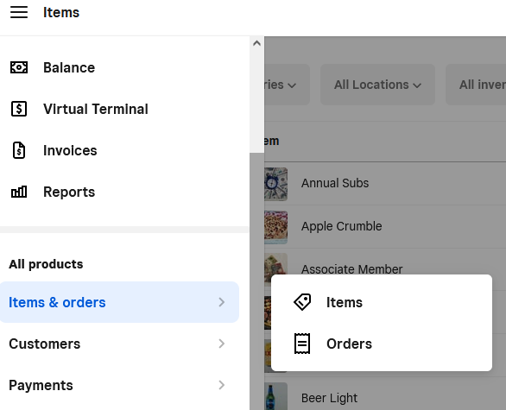
- Select the item you want to update, and select the “Manage Stock” link
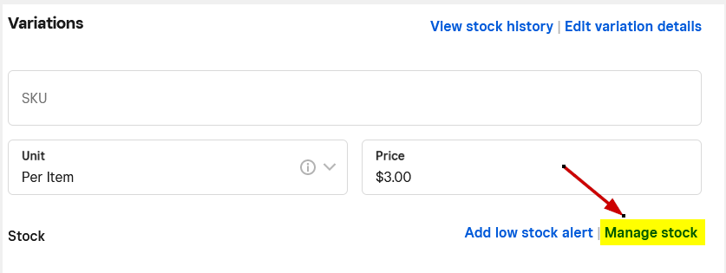
- Update the quantity on hand, and select the reason for the change
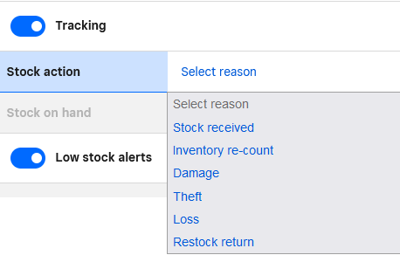
For incoming stock, this would be “Stock Received”
- Ensure you click the “Done” and then “SAVE” button at top of screen before you close the window.

