Oakbank Bowling Club

Work Instruction: MYOB Accounting System

Task: Record all financial transactions in MYOB, and generate financial statements
Performed By: Treasurer
Prerequisites:
- Access to the OBC bank accounts… Bank SA login required
- Access to the OBC MYOB login
- Access to the OBC Square account login
- Access to the OBC gmail account
- Understanding of basic book keeping principles
Inputs:
- Bank Statements (obtain on-line)
- Bank transactions … most will be automatically imported, some will need manual entry
- Square system sales and cash drawer reports
- Invoices received (usually via gmail)
Outputs:
- Current financial status and reports
Background:
In 2022, the club trialled both Xero and MYOB accounting systems. Each have pros and cons… for our club, Xero’s integration with the Square system resulted in a bill being generated every day we used the Square system, and this exceeded our monthly billing quota (on the el cheapo Xero plan). There being no apparent way around this, we were forced to revert to using MYOB.
This document is in NO WAY a comprehensive user guide for MYOB. The person who performs this function will either need to be already familiar with computerised accounting/book-keeping systems… or be really good mates with someone who is! There are plenty of resources on the web to consult also.
Accounting 101 Basics
This is super-simplified… but should be useful to the inexperienced.
- ALL transactions have both a DEBIT and a CREDIT entry, a bit like two sides of a coin. A “transaction” means “something happened”. Or, put differently, money MOVED from one place (account) to another account. If nothing moved… then there is NO TRANSACTION to record. Simple
- Some accounts INCREASE when you CREDIT them (and vice versa for DEBITS)
- Some accounts DECREASE when you CREDIT them. Ditto.
- This is really important… although it seems to be contradictory to the usual understand of “crediting an account”, but that’s just how it is… you just need to run with it.
- Recording a transaction really just means identifying when and where the money came from… and where it went to.
- For most things, our version of MYOB sort of hides this. If in doubt, you should consult someone who knows how accounting systems work (eg, an Accountant, Book-keeper… or a friendly colleague with a sage-like long white beard…)
Financial Statements
The Balance Sheet records all of the club’s Assets and Liabilities at a given point in time
The Profit & Loss statement shows all Income and Expenses for a specified period of time (like, a month, or year)
Integrations
Our MYOB system is integrated with two related systems:
- Square EFTPOS system
- Bank SA
What this means is, (almost) all activity from either system is AUTOMATICALLY imported into MYOB. The exception is our Bank SA Incentive Saver account. Our el cheapo MYOB license only allows limited integrations… the less frequently used Incentive Saver account had to be dropped, but there should only be 1 or 2 transactions per month on this account, which will need to be entered manually. The bulk of our activity (from the Square Stand) and Society Cheque account will all simply appear a day or two later, which reduces the amount of data entry work enormously.
The Actual Work…
OK, enough of the preliminaries… down to business. Typically, the routine tasks are
- Allocating income and expense transactions to the right account
- Reconciling the bank accounts
- Creating any other transactions (eg, recording anything NOT on the auto-feed from the bank or Square thingy)
- Creating financial statements as required (like, for presentation at Board meetings)
Anything else might warrant consulting an expert.
Allocating transaction to relevant accounts
This is a key component of maintaining “the books” of any organisation, and is the foundation for compiling accurate summaries of financial activity at the end of a period.
- Log into the MYOB Business Essentials portal. Login details supplied on a need-to-know basis!
- Get the most recent Bank Statements for both Society Cheque and Incentive Saver accounts from Bank SA You DO have a Bank SA profile and login, don’t you?
- View all Bank transactions: From the top menu in MYOB, go to Banking->Bank transactions
- Select the desired account from the drop-down… eg 1-1110 Society Cheque (or just leave it as “All”)
- Sometimes, you may need to Allocate an amount, like a payment, to a particular account. Say there was a line in the imported bank statement paying a supplier, like Optus, or SA Water. MYOB might need you to tell it which Expense account to record the payment against. Usually, this be simply a matter of selecting from a drop-down list of existing accounts. You can search for likely candidate accounts by typing something like “phone” or “water”, and then choosing the suggested account.
- You will typically see some transactions with a note saying “Allocate me”… this indicates MYOB does not yet know what the transaction relates to… what is about. In terms of my explanation above… MYOB knows where the money came FROM… but not where it went TO. So, you have to tell it… in one of two ways:
  - Click on the drop-down immediately to the right of the “Allocate me” text box, and select the appropriate account… like this. This is the easiest way to proceed…
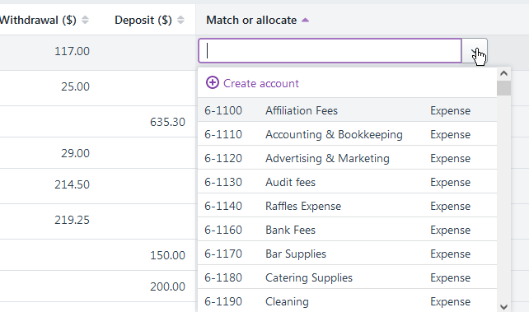
  - Alternatively, open the more general window to enter data… including Transfers… by clicking on the down-arrow at the far right of the row.
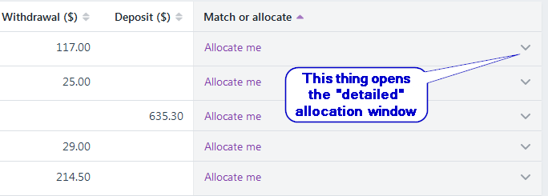
This allows entry of more complex options… like splitting an amount between two or more accounts.
  - Once all transactions have been allocated to the right account, you can proceed to the next important step…

Reconciling Bank Statements
- From MYOB’s top menu bar, go to Banking -> Reconcile Accounts
- Enter the date and balance FROM THE BANK STATEMENT
- Many transactions will have been magically matched already… if there is a reported “Out of Balance” amount, check that all valid transactions have been checked
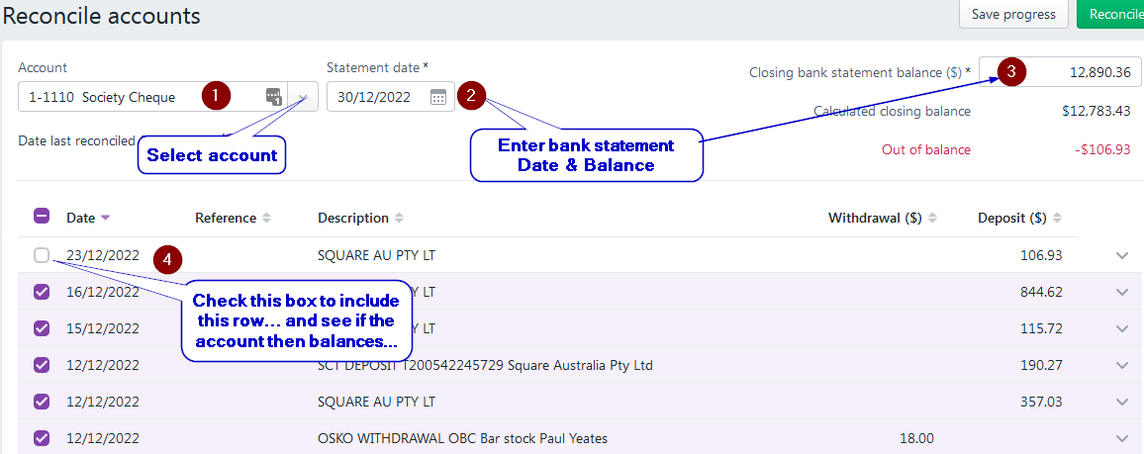
- If required, you may need to manually MATCH a bank transaction with a related journal entry… or, possibly, CREATE the required matching entry if it doesn’t yet exist <HOW> So, what is this actually doing? Remember, a transaction records
a) where money came FROM, and
b) where it went TO.
That really is all we are doing.

Creating New Journal Entries
Sometimes, you just need to do other things… like, raise an invoice. That would be under “Sales”.
Or maybe you just need to create one of the missing Incentive Saver bank transactions… that is, enter either a receipt or payment… Go to Banking -> Spend Money (or Receive Money… or Transfer Money) and enter the details from the bank statement. NOTE: we have a recurring TRANSFER of $50 from our Society Cheque to Incentive Saver account each and every month. You MUST enter this as a transfer… not “spending money”!
To record interest received for the month – that would be a Receive Money entry. This will debit the bank account, and credit the interest income account… increasing both.
Having done something like this, you should then be able to match this new entry with (say) an existing entry from the Society Cheque account’s list of bank transactions. You will know when you are all done when BOTH bank accounts reconcile. Give yourself a pat of the back and go have a coffee and a biscuit… or whatever!
Banking
From time to time, you will transfer surplus cash from the cashbox to the bank. (The Work Instruction “Managing Cash” may be useful. ) In terms of recording this, it is simply a matter of creating a transfer record in MYOB.
- Click on the down arrow thing at far right
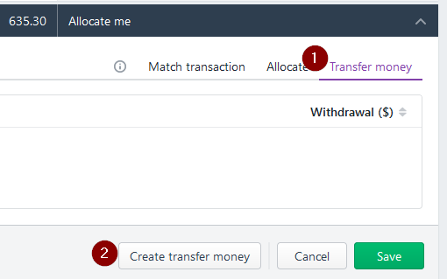
- Select “Transfer Money”
- In the popup window, select the source and destination accounts. The “from” account should be Square Cash Clearing… as that is the account automatically debited when we recognise cash sales.
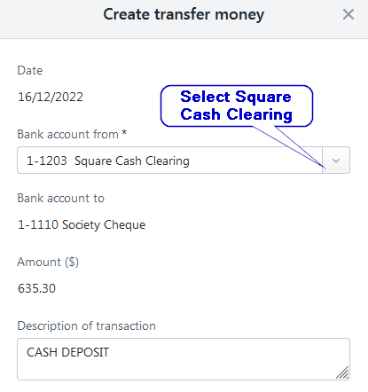
What else do I need to do?
To maintain an accurate picture of the profit from bar sales (including uniform sales), it is necessary to record the cost of what was sold. This is one of the few things our systems do not provide. See the related Work Instruction “Estimate Cost of Goods Sold” for details of how to obtain this - we will pick up here what you need to with that data, once calculated. And this is where my earlier remarks about debits and credits finally comes into play!
Let’s say the cost of Bar Stock sold for the last month is $1,250. What is needed is a General Journal entry that includes BOTH the following lines below.
- DEBIT 5-2100 Bar COS $1,250
- CREDIT 1-1150 Bar Stock $1,250
The net result of this will be to decrease the bar stock inventory account (we now have less stock on hand to sell), and increase the cost of sales expense account (which is offset by the revenue recorded when we sold drinks etc). That revenue will be automatically captured thanks to the Square integration. DO NOT ENTER IT MANUALLY!
To create this journal, go to Accounting->Create general journal. Date it, enter a description something like “Adjust stock”, and make sure you get the debits and credits the right way around! We will be debiting the expense/Cost of Sales account… and crediting the asset (inventory) account.
Below is an actual journal entry from November, 2022. Yours should look similar…
Note that you can (and probably should) include both bar sales AND uniform sales in the one General Journal… which should only be entered ONCE for the month.

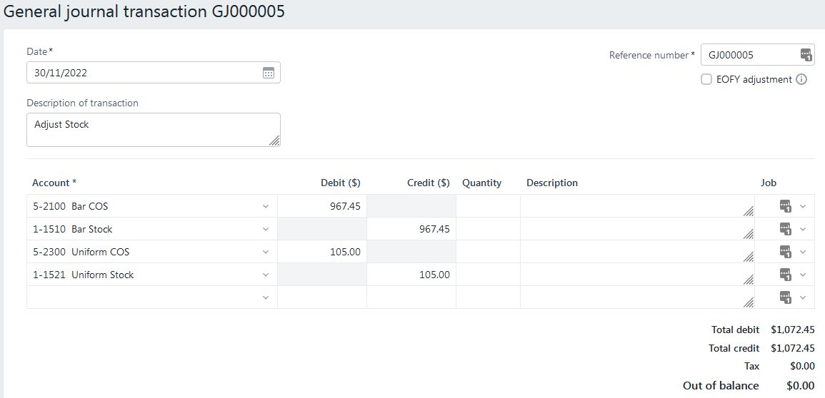
Reporting
So, it’s just past end of month, the Board meeting is in a couple of days and you need to provide the Treasurer’s Report… which will in large part be the financial statements, plus any relevant notes about significant items. It is presumed that at this stage, all your accounts reconcile… if not, you are not really ready to prepare final reports for publication… but you might want to run them for your own checking… to see if things “look correct”. Often, something will look “out of place”, you should investigate, and make any required alterations.
Go to Reporting->Favourite Reports, and select Balance Sheet or Profit & Loss. Select the desired date, or range of dates, and Export to PDF for publication when you are satisfied all is properly entered for the period.
These financial statements should preferably be emailed to the Secretary prior to the Board Meeting, but at a bare minimum, tabled at the Board Meeting, along with any other relevant information. It is assumed that the Secretary would forward all such documents to other Board Members.

