Work Instruction: Website Maintenance

Task: Maintain Website
Prerequisites:
- Internet connection
- Website login credentials
- Familiarity with IT systems and WordPress desirable
Inputs:
- New content, images etc
Outputs:
- An updated website!
Procedure:
- Log onto the club’s website management system, which is a WordPress site hosted by Bowls Australia, at this URL:
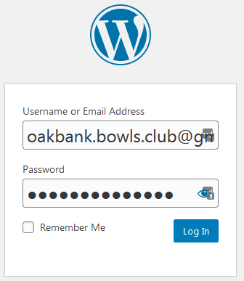
Username: oakbank.bowls.club@gmail.com
Password: provided to those who need it…
The areas most likely to need updating are (at this point in time at least) our PAGES, and the content of those pages, which may refer to MEDIA that has been loaded into the WordPress system. The system has many Pages, not all of which are displayed. Pages can be in various states… e.g. Draft, Published etc. To be visible on our site, a page would need to be both Published, and if it is under a drop-down menu… it needs to be linked to the drop-down.
But… first things first.
- Open a list of all our Pages
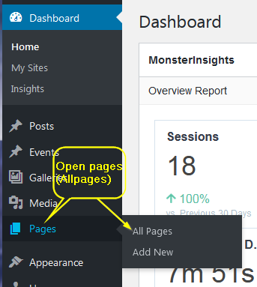
- This pic shows a few of some of our pages…
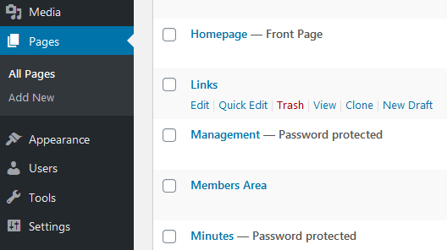
The selected page has a row of actions you can take… Edit Quick Edit Trash etc. Mostly you will use Edit, sometimes Quick Edit.
For instructional purposes, this doc will show first how to update content on our Links page, and later, add media to another page.
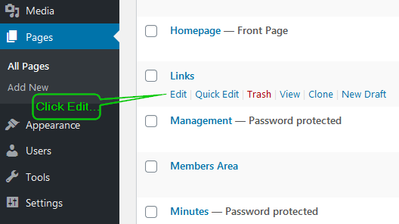
- The current page content is displayed…
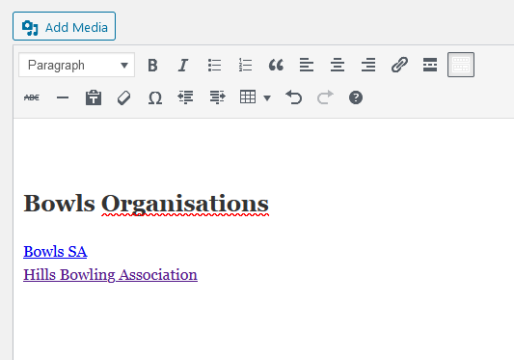We are going to add a link to our Facebook site…and add in a link to Bowls Australia’s website. Click the Insert Link icon
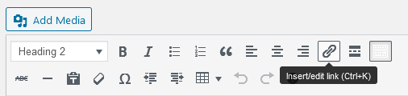
I added in a bit of text, plus two links to useful sites. Our new page now looks like this:
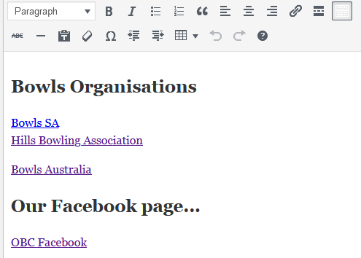
When you have completed editing, click “Update” in the panel on the right-hand side of screen to push the new content as the published page
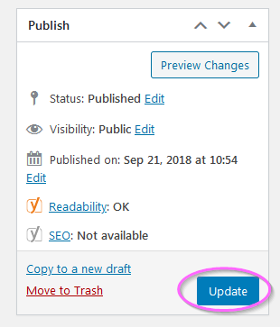
- Easy! So… what about adding some images? The most general approach is to add the desired image to the MEDIA section, which is a folder that contains all of the pictures, documents etc that we have for our club. (A copy of these files will then be held on the Bowls Australia system). Then inserting the newly created Media object into a page is a snap…
First, let’s add a document into our Media collection.

  - Click the Media button on the LHS navigation bar
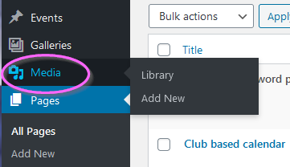

  - Then select the appropriate folder and add the media item…
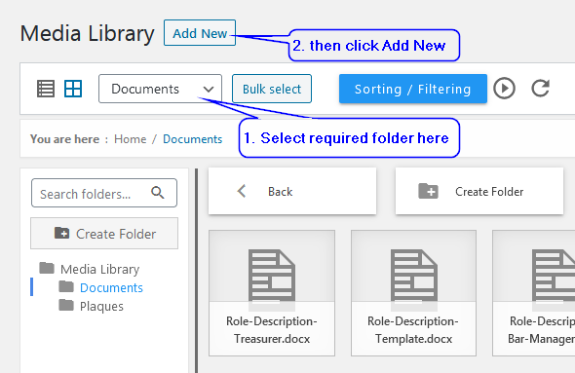
  - Drag&Drop files or click the Select Files button…
Note: Some document types are not permitted… but JPG images, Word/Excel docs etc should be fine

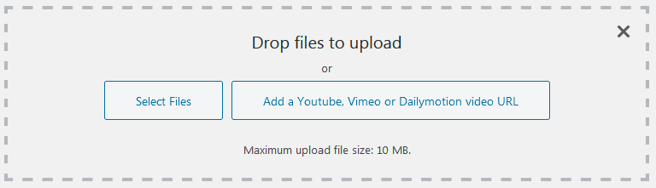

  - We are going to add this document to our Work Instructions page, for the benefit of anyone who needs to perform the task (eg, newly appointed committee members) and needs help.
Open the Work Instructions page, then click the Add Media button…
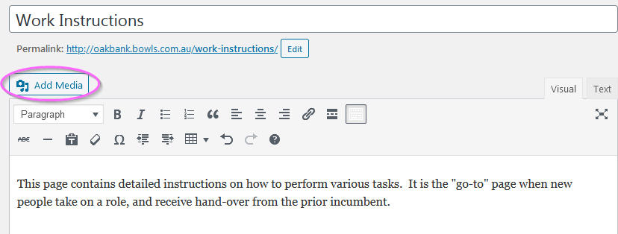
  - Now, Navigate to the desired document (or image) …

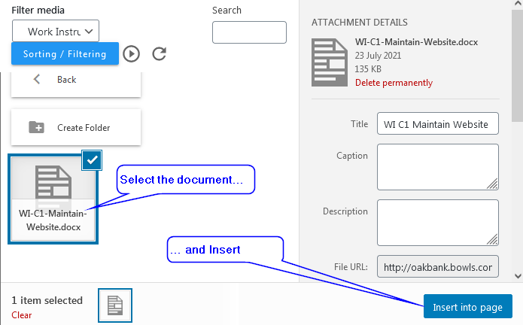

  - You can confirm if all your edits are working as expected by clicking the Preview Changes button
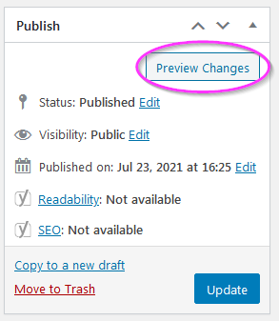
  - Don’t forget to Update the Page!
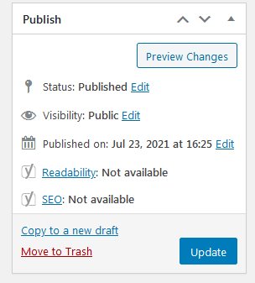

- And finally, open the website to ensure everything looks right!
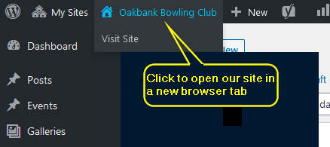
- Congratulations… you did it!
Updating Sponsors Sidebar
At some point, sponsors will change… and updating this is fairly well hidden. So, if you need to update this… this section is for you
The key is to find where this is done… and it is buried under the Widgets page, which is shown under the Appearance menu on the LHS panel.
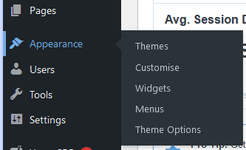
Click on the Widgets line… and you will see a collection of widgets… tools you can use to do cool stuff on pages. At the far right, there is the Theme Sidebar… and under that, “Default Sidebar”.
This has a gallery, which I’ve named “Our Sponsors”… which is NOT shown under the main Galleries listing (confusing, I know…), but on the widgets page, you will find an Edit Gallery button… where you can add/delete sponsor’s logos etc.

Revision History
Date | Version | Change | Author
23/7/21 | 1.0 | Initial document | T. Norman
9/1/23 | 1.1 | Removed WordPress login password  Added section on updating sponsors gallery | T. Norman

