Oakbank Bowling Club

Work Instruction: A1 Cash Management

Task: Manage the cash held in the club’s cash register, kitty and banking
Performed By: Treasurer or Bar Manager
Prerequisites:
- Access to the club’s cashbox. This is secured in the club’s safe. The safe’s Passcode will NOT be recorded in ANY unsecure place!
- Bank Deposit book and optionally a deposit card from Bank SA (for deposits at the PO)
- Basic ability to use a simple Excel spreadsheet
Inputs:
- OBC cash box (aka “kitty”)
- Treasurer’s Kitty Bank Calculator spreadsheet
Outputs:
- A bank deposit summary page, showing starting cash in the kitty, a breakdown of notes and coins being deposited at bank, and the resulting kitty balance after banking
Procedure:
This process is intended to be performed whenever a bank deposit is made, but the basic counting function can be used any time you want to correctly tally up the cash.
We are going to divide the cash into two “pots”… one, that we will deposit at the bank… the remainder will be what becomes the new kitty, to be held over in the cash box.
It is not essential to use the related Excel spreadsheet, but is recommended – particularly when preparing a bank deposit.
- Before you begin, ensure that all cash tendered, e.g. from bar sales, raffles, tea & coffee money etc, has been entered via the Square terminal. (Use of the Square system is covered in depth in a separate Work Instruction)
- Remove the desired bar float and set this aside, topping up any shortage from the cash box if required. More details in the Square Terminal document.
- Open the “Kitty Cash Calculator” for the current year. This Excel document can be found on the club’s laptop, in the Treasurer’s folder. The filename will be something like “Kitty Cash Calculator 20xx.xlsm”. Note… it is important that you open the document with “.xlsm” extension… it contains the smarts to make this process really easy. It should look like this:
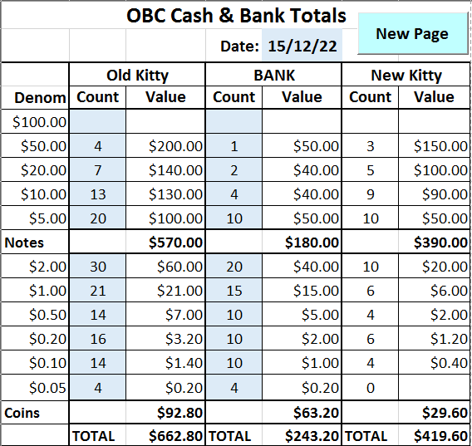
Go to the last tab, and click on the “New Page” button. This will create a new, blank sheet and rename it to today’s date. See the note below for what to do if something odd happens… like, you end up with multiple tabs for the same date… that’s best avoided to prevent confusion!
- Gather all the cash from the cashbox & cash register (excluding the bar float), separate the different denominations, and count how many of each denomination you have… DON’T count the dollar value!
- Enter the counts in the blue cells in the spreadsheet “Old Kitty”… Column B. NOTE: The system is designed so you CANNOT enter data into cells with formula that do all the spiffy calculations… blue cells only!! Mouse-click, tab or use arrow keys to move to the next cell
- Enter the counts to go to the bank into Column D… BANK Count. The system won’t allow you to bank more notes/coins than is stated as your starting cash position.
- The system does all the calculation for you… showing totals for notes and coins (the bank will love you for this)
- Ensure the date is correct in cell E2… and SAVE the spreadsheet
- PRINT the sheet to take with you to the bank
- Put the remaining cash back in the cashbox and lock it away in the safe
- Make the deposit at a Bank SA branch (or at the nearest Post Office)
Note: If you do end up with more than one tab for a particular date, which might happen if you press the “New Page” button more than once on the same day, you should delete or rename the extra tab. Do this by right-clicking on the tab’s name, and select Delete or Rename.
And that’s it. Written out in gory detail, it sounds complicated… it really isn’t. Try it…
Please provide any feedback on this process to Trevor Norman, or the current Treasurer.

